WEEK 15-01

PRACTICE SESSION CODING

Name: SRI RAMKANNA M

Roll No: 241801275

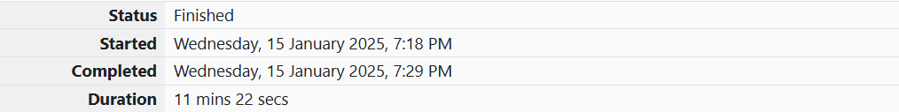

1.PROBLEM STATEMENT:

Given an array of integers, reverse the given array in place using an index and loop rather than a built-in function. Example arr = [1, 3, 2, 4, 5] Return the array [5, 4, 2, 3, 1] which is the reverse of the input array. Function Description Complete the function reverseArray in the editor below. reverseArray has the following parameter(s): int arr[n]: an array of integers Return int[n]: the array in reverse order Constraints 1 ≤ n ≤ 100 0 < arr[i] ≤ 100 Input Format For Custom Testing The first line contains an integer, n, the number of elements in arr. Each line i of the n subsequent lines (where 0 ≤ i < n) contains an integer, arr[i]. Sample Input For Custom Testing 5 1 3 2 4 5 Sample Output 5 4 2 3 1 Explanation The input array is [1, 3, 2, 4, 5], so the reverse of the input array is [5, 4, 2, 3, 1].

PROGRAM CODING:

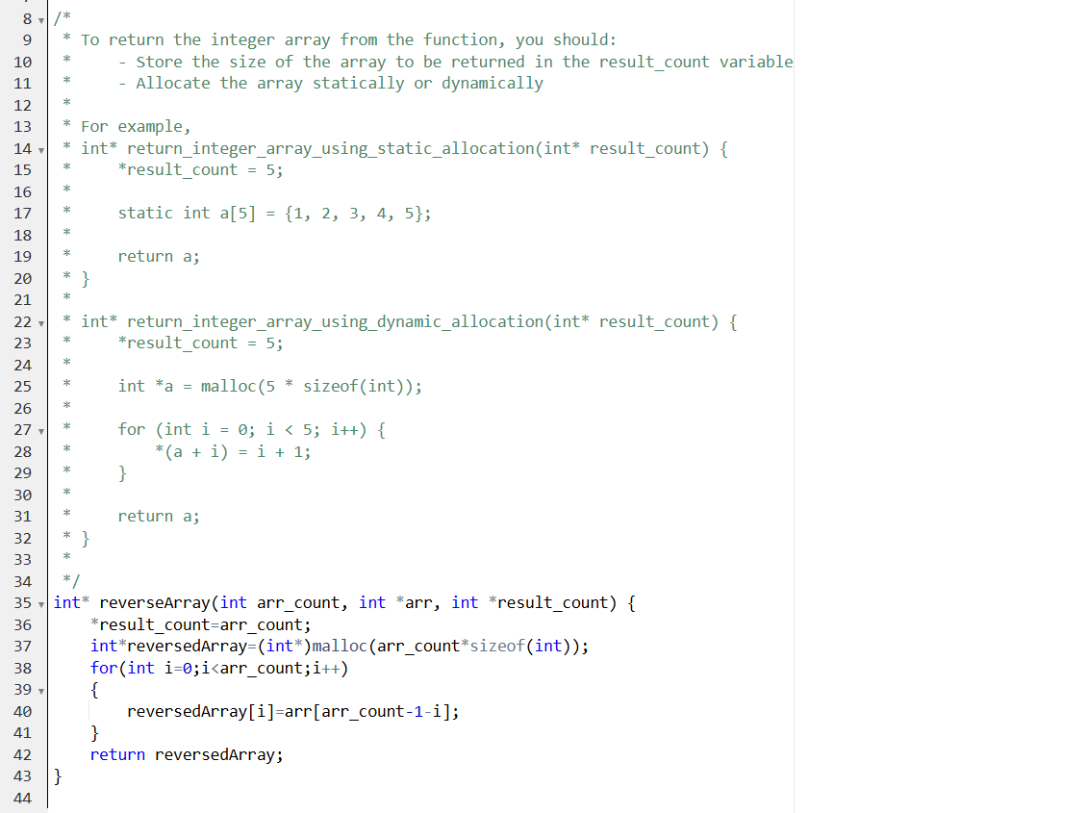

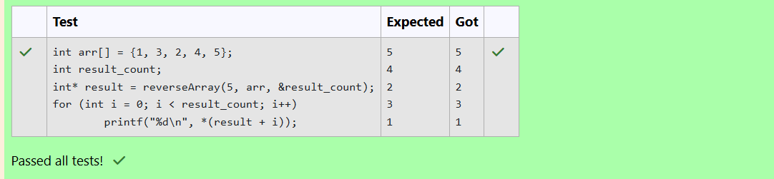

2. PROBLEM STATEMENT:

An automated cutting machine is used to cut rods into segments. The cutting machine can only hold a rod of minLength or more, and it can only make one cut at a time. Given the array lengths [] representing the desired lengths of each segment, determine if it is possible to make the necessary cuts using this machine. The rod is marked into lengths already, in the order given. Example n = 3 lengths = [4, 3, 2] minLength = 7 The rod is initially sum(lengths) = 4 + 3 + 2 = 9 units long. First cut off the segment of length 4 + 3 = 7 leaving a rod 9 - 7 = 2. Then check that the length 7 rod can be cut into segments of lengths 4 and 3. Since 7 is greater than or equal to minLength = 7, the final cut can be made. Return "Possible". Example n = 3 lengths = [4, 2, 3] minLength = 7 The rod is initially sum(lengths) = 4 + 2 + 3 = 9 units long. In this case, the initial cut can be of length 4 or 4 + 2 = 6. Regardless of the length of the first cut, the remaining piece will be shorter than minLength. Because n - 1 = 2 cuts cannot be made, the answer is "Impossible". Function Description Complete the function cutThemAll in the editor below. cutThemAll has the following parameter(s): int lengths[n]: the lengths of the segments, in order int minLength: the minimum length the machine can accept Returns string: "Possible" if all n-1 cuts can be made. Otherwise, return the string "Impossible". Constraints • 2 ≤ n ≤ 105 • 1 ≤ t ≤ 109 • 1 ≤ lengths[i] ≤ 109 • The sum of the elements of lengths equals the uncut rod length. Input Format For Custom Testing The first line contains an integer, n, the number of elements in lengths. Each line i of the n subsequent lines (where 0 ≤ i < n) contains an integer, lengths[i]. The next line contains an integer, minLength, the minimum length accepted by the machine. Sample Input For Custom Testing STDIN Function ----- -------- 4 → lengths[] size n = 4 3 → lengths[] = [3, 5, 4, 3] 5 4 3 9 → minLength= 9 Sample Output Possible Explanation The uncut rod is 3 + 5 + 4 + 3 = 15 units long. Cut the rod into lengths of 3 + 5 + 4 = 12 and 3. Then cut the 12-unit piece into lengths 3 and 5 + 4 = 9. The remaining segment is 5 + 4 = 9 units and that is long enough to make the final cut

PROGRAM CODING:

